Final Exam

Name : Grade:

Section 1 - Speaking

1) Eggplant Onion Pea Broccoli

Summer Fall Winter Warm

Cool Cold Spring Hot

2) I am not very good. I am very good.

Today is May 11th. Spring is coming.

Section 2 - Writing

1) Matches the English words in Column A with its Chinese Pinyin in Column B.

Column A Column B

Spring qié zi

Eggplant wān dòu

Pea chūn tiān

Cold lěng

2）Matches the Seasons in Column A with its feature in Column B.

Column A Column B

chūn tiān rè

dōng tiān liáng kuɑi

xià tiān nuǎn huo

qiū tiān lěng

3) Writes the corresponding Chinese words in the writing gird base on their meanings.

abundant 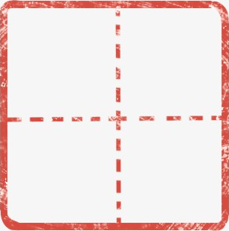 half  thousand